Nine per cent of PCB boards purchased over the Internet from the Far East have some defect. From a large consignment of boards, 50 are chosen at random. What is the probability that:
- 5 or more boards have some defect?
- Exactly 3 boards are defective?
- Less than 2 boards are defective?
- If more than 8 boards from the 50 were defective what action would you take? (justify)

Flaws occur in a heavy duty industry carpet at the rate of 15 per 10 square metre section. Calculate the probability that:
- 3 or more flaws will occur in a one square metre section
- Exactly 4 flaws will occur in a 10 metre square section
- 14 or less flaws will occur in a 20 square metre section

There is a constant probability of 0.10 that the power supply in telecoms network will not start. You are requested to calculate the probability that the power supply will fail the 5th time it is activated.

Under what circumstances is it appropriate to use the binomial distribution when calculating probabilities?

Flextronics supply PCB boards to Dell. You are a production manager with Dell. There is a constant probability of 0.01 that a board will be defective. You select 20 boards at random. What is the probability that:
- 0 boards will be defective
- 1 or more boards will be defective
- 2 or less boards will be defective

Flaws occur in an LCD display at the rate of 0.5 per square mm. Calculate the probability that:
- exactly 2 flaws will occur in a square mm section
- exactly 3 flaws will occur in a 5 square mm section
- 5 or more flaws will occur in a 10 square mm section

There is a constant probability of 0.05 that the power supply in a server network will fail. You are required to calculate the probability that the power supply will fail the 4th time it is switched on.

In this question we are dealing with a binomial distribution and a successful outcome is finding a defective board

Therefore 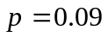 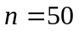

(i)

5 or more boards have some defect

Look up the tables and find
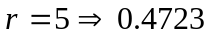

Probability of 5 or more boards being defective is 0.4723

(ii)

Exactly 3 boards are defective

Look up the tables and find

Probability of Exactly 3 boards being defective is 0.1698

(iii)

Less than two boards

Look up the tables and find

Probability of less than 2 boards being defective is 0.0532

(iv)

First we find the probability of getting more than 8 boards defective

Look up the tables and find

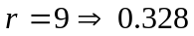

Probability of more than 8 boards being defective is 0.0328

This would seem to indicate that there is aproximately a 3% chance of getting more than 8 defective boards. Normally we would not expect an event with a probability of less than 5% to occur. If we were to find more than 8 defective boards we would need to question the claim that the probability of finding a defective board is 9%.

(b)

This time we are dealing with a poisson distribution

(i)

3 or more flaws in a one square metre section

We first need to find the expected value so that we can use the tables

We are given
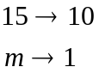
cross multiply to get
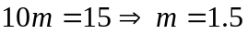

Look up the tables with 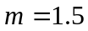 and 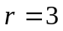

The probability of 3 or more flaws is 0.1912

(ii)

Exactly 4 flaws will occur in a 10 metre square section

This time we don’t need to calculate as we are given the expected value for a 10 metre square section.

Look up the tables with 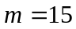 and

The probability of exactly 4 flaws is 0.0007

(iii)

14 or less flaws will occur in a 20 square metre section

Again we first need to find the expected value so that we can use the tables

We are given
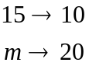
cross multiply to get
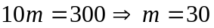

Look up the tables with 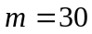 and

The probability of 14 or less flaws is 0.0009

(c)

This time we are dealing with a Geometric distribution

Given the probability of not starting is 0.1

Therefore the probability of starting is 0.9

The formula for a geometric distribution is

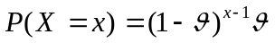

where in this case is the probability of not starting

we get 